**VirtIO Rng**

**1 Spec**

编写Virtio Driver第一步是根据标准确认设备的ID，Virtqueue的个数和作用，操作的模式，比如RNG设备在标准中的描述如下图，可以知道RNG设备的ID是4，只有一个virtqueue，交互的方式是driver将buffer传递给device，device将随机数据填充到该buffer中后返回给driver

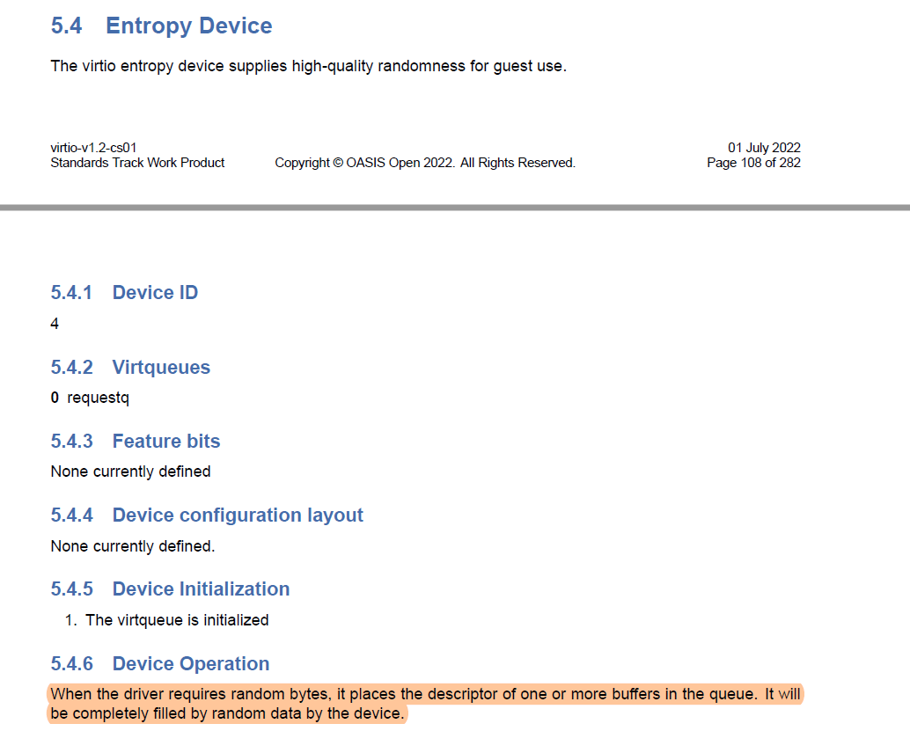

**2 初始化**

1. 驱动需要实现一个virtio_register_rng_driver()函数，在virtio_register_drivers()函数中调用，如下：

|  |
| --- |
| C int virtio_register_drivers(void) {  int ret;  ... #ifdef CONFIG_DRIVERS_VIRTIO_RNG  ret = virtio_register_rng_driver();  if (ret < 0)  {  vrterr("virtio_register_rng_driver failed, ret=%d\n", ret);  } #endif  ...  return ret; } |

1. 驱动在virtio_register_rng_driver()中调用virtio_register_driver()将自己的驱动注册到virtio总线中去；
2. Virtio Device在初始化时，会将设备注册到virtio总线中去，触发virtio_rng_driver_probe函数执行驱动的初始化，初始化完后会注册/dev/random到Vela的VFS中去；

**3 数据结构**

比较简单，只有设备名字

|  |
| --- |
| C struct virtio_rng_priv_s {  FAR struct virtio_device *vdev;  char name[NAME_MAX]; }; |

**4 Functions**

**virtio_register_rng_driver()**

|  |
| --- |
| C static struct virtio_driver g_virtio_rng_driver = {  LIST_INITIAL_VALUE(g_virtio_rng_driver.node), /* node */  VIRTIO_ID_ENTROPY, /* device id */  virtio_rng_probe, /* probe */  virtio_rng_remove, /* remove */ };  int virtio_register_rng_driver(void) {  return virtio_register_driver(&g_virtio_rng_driver); } |

**virtio_rng_driver_probe()**

|  |
| --- |
| C static int virtio_rng_probe(FAR struct virtio_device *vdev) {  FAR struct virtio_rng_priv_s *priv;  FAR const char *vqnames[1];  vq_callback callback[1];  int ret;   priv = kmm_zalloc(sizeof(*priv));  if (priv == NULL)  {  vrterr("No enough memory\n");  return -ENOMEM;  }   priv->vdev = vdev;  vdev->priv = priv;   /* Call openamp api to intialize the virtio deivce */   virtio_set_status(vdev, VIRTIO_CONFIG_STATUS_DRIVER);  virtio_set_features(vdev, 0);  virtio_set_status(vdev, VIRTIO_CONFIG_FEATURES_OK);   vqnames[0] = "virtio_rng_rx";  callback[0] = virtio_rng_done;  ret = virtio_create_virtqueues(vdev, 0, 1, vqnames, callback);  if (ret < 0)  {  vrterr("virtio_device_create_virtqueue failed, ret=%d\n", ret);  goto err_with_priv;  }   virtio_set_status(vdev, VIRTIO_CONFIG_STATUS_DRIVER_OK);  virtqueue_enable_cb(vdev->vrings_info[0].vq);   /* Register NuttX driver */   if (g_virtio_rng_idx == 0)  {  strlcpy(priv->name, "/dev/random", NAME_MAX);  }  else  {  snprintf(priv->name, NAME_MAX, "/dev/random%d", g_virtio_rng_idx);  }   ret = register_driver(priv->name, &g_virtio_rng_ops, 0444, priv);  if (ret < 0)  {  vrterr("Register NuttX driver failed, ret=%d\n", ret);  goto err_with_virtqueue;  }   g_virtio_rng_idx++;  return ret;  err_with_virtqueue:  virtio_reset_device(vdev);  virtio_delete_virtqueues(vdev); err_with_priv:  kmm_free(priv);  return ret; } |

**g_rng_ops**

rng只需要实现read的operation即可，如下

|  |
| --- |
| C static const struct file_operations g_virtio_rng_ops = {  NULL, /* open */  NULL, /* close */  virtio_rng_read, /* read */  NULL, /* write */  NULL, /* seek */  NULL, /* ioctl */  NULL, /* mmap */  NULL, /* truncate */  NULL, /* poll */ #ifndef CONFIG_DISABLE_PSEUDOFS_OPERATIONS  NULL, /* unlink */ #endif }; |

**static ssize_t virtio_rng_read(FAR struct file *filep, FAR char *buffer, size_t buflen)**

描述：将user的buffer传递给device端，等待device端填充随机数，device端返回后，buffer被填充为随机数，之后返回给user

|  |
| --- |
| C struct virtio_rng_cookie_s {  sem_t sem;  size_t len; };  static ssize_t virtio_rng_read(FAR struct file *filep, FAR char *buffer,  size_t buflen) {  FAR struct virtio_rng_priv_s *priv = filep->f_inode->i_private;  FAR struct virtqueue *vq = priv->vdev->vrings_info[0].vq;  struct virtio_rng_cookie_s cookie;  struct virtqueue_buf vb;  int ret;   /* Init the cookie */   cookie.len = 0;  nxsem_init(&cookie.sem, 0, 0);   /* Add the input buffer to the virtqueue, and the cookie as the virtqueue  * cookie. (virtqueue_get_buffer() will return cookie).  */   vb.buf = buffer;  vb.len = buflen;  ret = **virtqueue_add_buffer(vq, &vb, 0, 1, &cookie);**  if (ret < 0)  {  return ret;  }   /* Notify the other side to process the added virtqueue buffer */   **virtqueue_kick(vq);**   /* Wait fot completion */   nxsem_wait_uninterruptible(&cookie.sem);  return cookie.len; } |

**static void virtio_rng_done(FAR struct virtqueue *vq)**

描述：在device端填充完成后，通知driver端，触发该函数

|  |
| --- |
| C static void virtio_rng_done(FAR struct virtqueue *vq) {  FAR struct virtio_rng_cookie_s *cookie;  uint32_t len;   /* Get the buffer, virtqueue_get_buffer() return the cookie added in  * virtio_rng_read().  */   cookie = virtqueue_get_buffer(vq, &len, NULL);  if (cookie != NULL)  {  /* Assign the return length */   cookie->len = len;   /* Read completed, post the sem */   nxsem_post(&cookie->sem);  } } |

QEMU上的配置和使用参考[Rng](https://xiaomi.f.mioffice.cn/wiki/wikk4icnzDocTXLwD1nM6w8GIhh)，驱动设计参考[RNG](https://xiaomi.f.mioffice.cn/wiki/wikk4HzZp7gQCxwe5eMhl0Znu4b) 。